**Inventory Physical Count** is an actual count of items in the inventory.

**Adding Physical Counts**

To add a new **Physical Count**, follow these steps:

1. Click **Add New**

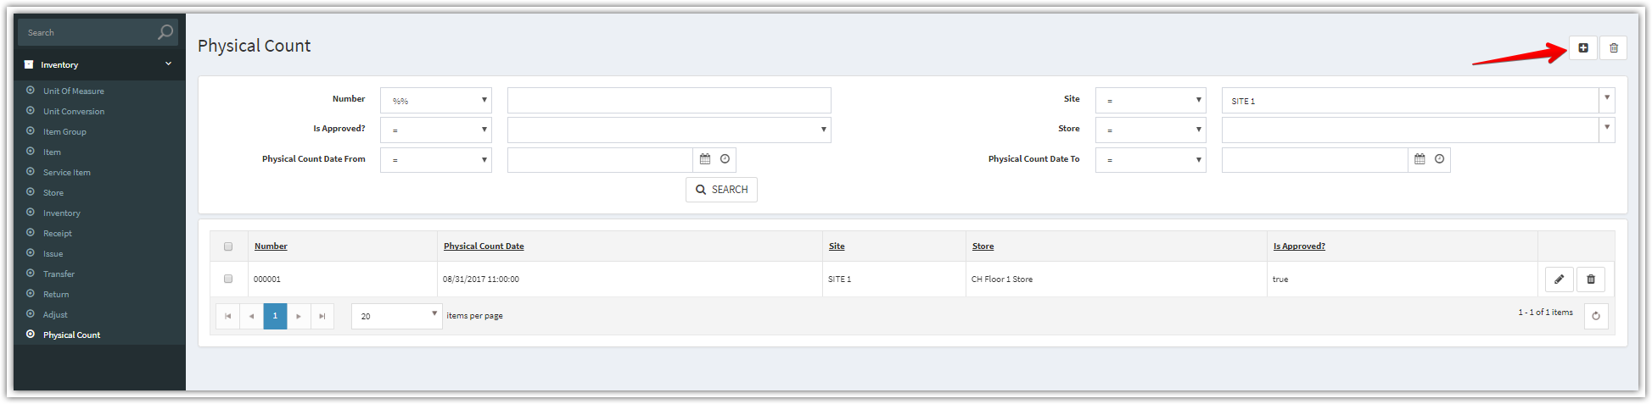

1. Complete the applicable data fields. * denote for required fields. Then click **Save.**

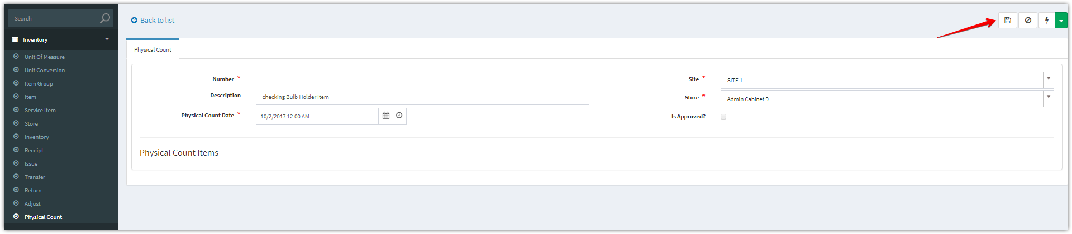

1. After clicking “**Save**” button. Add new items

Click **Add Multiple** to add multiple items

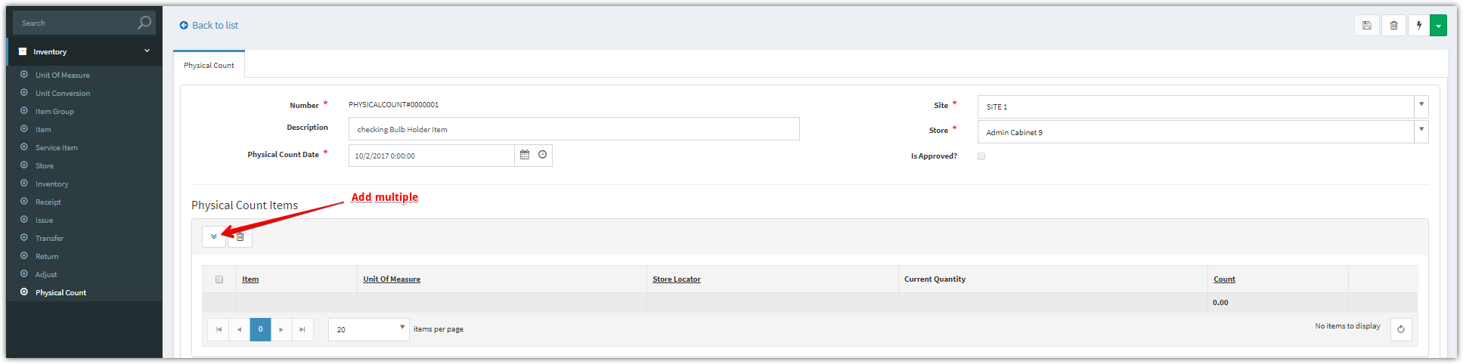

Based on the site and store of this physical count, we will load these items related to this site and store.

**Add Multiple**

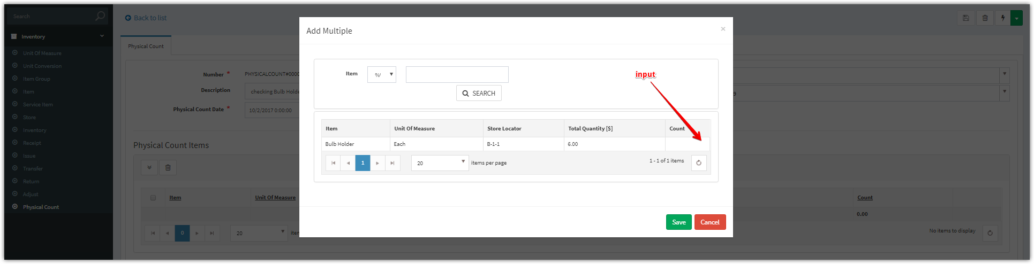

1. Click “**Approve**” button to approve for this receipt

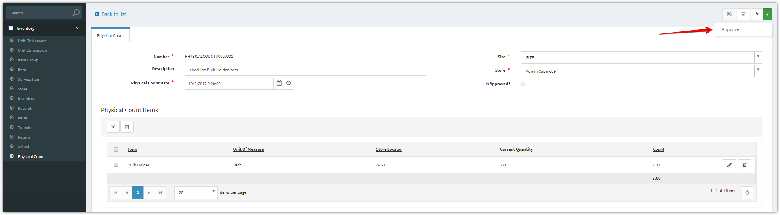

1. After approved, we checked and saw that the “**IsApproved’** checkbox was checked.

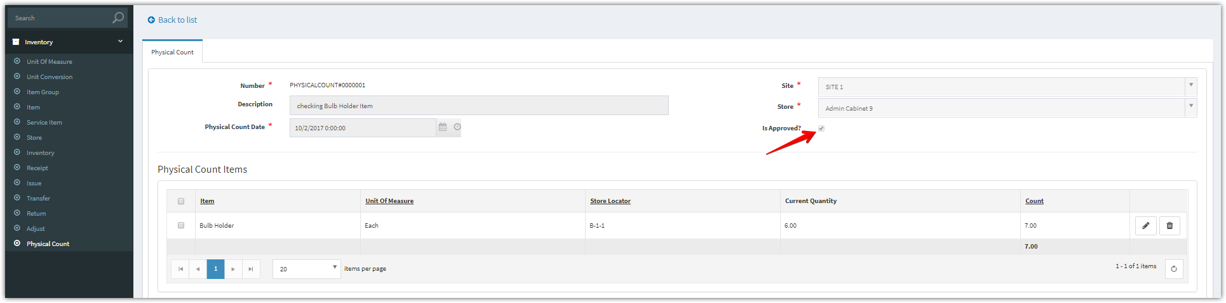

Besides, a new adjust will be generated from this physical count.

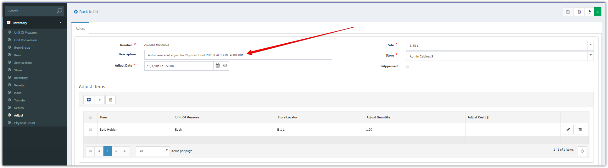

In order to approve for this adjust. Please see Adjust Inventory for more details.